# Supplemental file 3: Statistics Report for Signal Quality Analysis

*“*In a mixed-effects *model of signal quality over time (individual as a random effect), we found a significant interaction between signal quality over time and version (p=0.0366*).”*

## Signal Quality vs. Day and Version

**Dataset:** 05_SignalData_binned.csv - Signal quality data binned by day for each animal  
**Model:** Mixed-effects  
**Random Effect:** Seal ID  
**Response variable (y):** Mean Standardized (SWS δ/REM δ) Signal Quality per day  
**Fixed Effects:** Day, Version, Version*Day

| **Source** | **Nparm** | **DFNum** | **DFDen** | **F Ratio** | **Prob > F** |
| --- | --- | --- | --- | --- | --- |
| Day | 1 | 1 | 31.1 | 8.441232 | 0.0067 |
| Version | 2 | 2 | 7.4 | 0.204556 | 0.8195 |
| Version*Day | 2 | 2 | 31.6 | 3.679011 | 0.0366 |

*“V2 displayed a significant negative trend over time (V2: slope= -3.538±1.016 p=0.032*), V1 and V3 did not significantly degrade over time (V1: slope= -1.807±1.682 p=0.3951; V3: slope= -0.7695±0.5053 p=0.1486).”*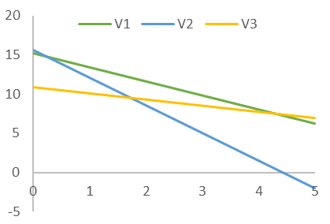

## Signal Quality vs. Day by Version

**Dataset:** 05_SignalData_binned.csv - Signal quality data binned by day for each animal  
**Model:** Mixed-effects  
**Random Effect:** Seal ID  
**Response variable (y):** Mean Standardized (SWS δ/REM δ) Signal Quality per day  
**By:** Version  
**Fixed Effects:** Day, Version, Version*Day

| **By** | **Fixed Effect** | **Estimate** | **Std Error** | **Prob>|t|** | **Random Effect** |
| --- | --- | --- | --- | --- | --- |
| V1 | Day | -1.80736 | 1.682471 | 0.3951 | Seal.ID |
| V2 | Day | -3.53795 | 1.016372 | 0.0032 | Seal.ID |
| V3 | Day | -0.76949 | 0.505302 | 0.1486 | Seal.ID |

*“Therefore, there was an interaction between location and version (p=0.0026*).”*

## 

## Signal Quality vs. Location and Version

**Dataset:** 05_SignalData_paired.csv - Signal quality data per each sleep cycle for each animal  
**Model:** Mixed-effects  
**Random Effect:** Seal ID  
**Response variable (y):** Standardized (SWS δ/REM δ) Signal Quality per sleep cycle  
**Fixed Effects:** Day, Version, Version*Day

| **Source** | **Nparm** | **DFNum** | **DFDen** | **F Ratio** | **Prob > F** |
| --- | --- | --- | --- | --- | --- |
| Location | 1 | 1 | 690.8 | 37.20367 | <.0001 |
| Version | 2 | 2 | 8.2 | 0.171145 | 0.8456 |
| Location*Version | 2 | 2 | 682.6 | 5.985103 | 0.0026 |

“Signal quality was significantly lower in water than on land for V1 (p=0.0012*) and V2 (p<.0001*), but we were able to minimize the impact of water intrusion on signal quality by V3 (p=0.9753) (Figure 12C-D).”

## Signal Quality vs. Location and Version

**Dataset:** 05_SignalData_paired.csv - Signal quality data per each sleep cycle for each animal  
**Model:** Tukey HSD All Pairwise Comparisons  
**Random Effect:** Seal ID  
**Response variable (y):** Standardized (SWS δ/REM δ) Signal Quality per sleep cycle  
**Fixed Effects:** Version*Location

| **Location** | **Version** | **-Location** | **-Version** | **Difference** | **Std Error** | **Prob>|t|** |
| --- | --- | --- | --- | --- | --- | --- |
| LAND | V1 | LAND | V2 | 0.8131 | 4.608024 | 1 |
| LAND | V1 | LAND | V3 | 6.2929 | 4.73421 | 0.7687 |
| LAND | V1 | WATER | V1 | 8.7626 | 2.215224 | 0.0012 |
| LAND | V1 | WATER | V2 | 11.1216 | 4.722662 | 0.1739 |
| LAND | V1 | WATER | V3 | 7.8615 | 5.119075 | 0.6412 |
| LAND | V2 | LAND | V3 | 5.4798 | 2.793369 | 0.3656 |
| LAND | V2 | WATER | V1 | 7.9495 | 4.9431 | 0.5934 |
| LAND | V2 | WATER | V2 | 10.3085 | 1.478258 | <.0001 |
| LAND | V2 | WATER | V3 | 7.0484 | 3.405157 | 0.3044 |
| LAND | V3 | WATER | V1 | 2.4697 | 5.060939 | 0.9966 |
| LAND | V3 | WATER | V2 | 4.8287 | 2.978686 | 0.5848 |
| LAND | V3 | WATER | V3 | 1.5686 | 2.087557 | 0.9753 |
| WATER | V1 | WATER | V2 | 2.359 | 5.050139 | 0.9972 |
| WATER | V1 | WATER | V3 | -0.9011 | 5.422664 | 1 |
| WATER | V2 | WATER | V3 | -3.2601 | 3.558757 | 0.9424 |

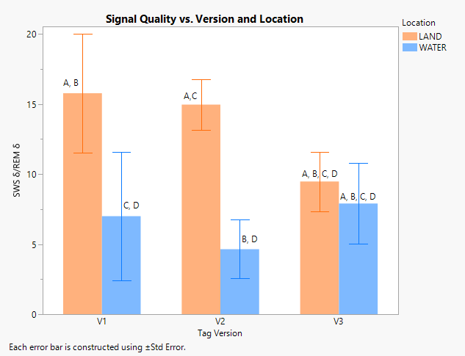

**Figure S1.** Least squares means estimates of signal quality (mean SWS δ/REM δ per sleep cycle) across versions and locations demonstrating significant differences between land and water for V1 and V2, but not V3. Each error bar is constructed using ±Std Error. Levels not connected by the same letter are significantly different.

“When comparing signal quality across ages on land (where differential water intrusion would not impact signal quality), we found lower signal quality in the oldest animals (2-3 years old) compared to the youngest animals (0-1 year-old), though this was not significant (Δ SWS δ/REM δ= 5.673±2.628; p<.2593; Figure 12E). 1-2 year-olds were monitored primarily with early iterations of version 2, which had the most significant discrepancy between land and water signal quality and therefore showed the most significant decrease in signal quality due to water intrusion (Δ SWS δ/REM δ= 15.01±1.753; p<.0001*; Figure 12F).”

## Signal Quality vs. Location and Age

**Dataset:** 05_SignalData_paired.csv - Signal quality data per each sleep cycle for each animal  
**Model:** Tukey HSD All Pairwise Comparisons  
**Random Effect:** Seal ID  
**Response variable (y):** Standardized (SWS δ/REM δ) Signal Quality per sleep cycle  
**Fixed Effects:** Age*Location

| **AGE** | **Location** | **-AGE** | **-Location** | **Difference** | **Std Error** | **Prob>|t|** |
| --- | --- | --- | --- | --- | --- | --- |
| (0,1] | LAND | (0,1] | WATER | 4.9285 | 1.634513 | 0.0318 |
| (0,1] | LAND | (1,2] | LAND | -3.1931 | 2.237878 | 0.7106 |
| (0,1] | LAND | (1,2] | WATER | 11.8089 | 2.752095 | 0.0003 |
| (0,1] | LAND | (2,3] | LAND | 6.6931 | 2.811521 | 0.1646 |
| (0,1] | LAND | (2,3] | WATER | 8.0595 | 3.319076 | 0.1481 |
| (0,1] | WATER | (1,2] | LAND | -8.1216 | 2.515575 | 0.0164 |
| (0,1] | WATER | (1,2] | WATER | 6.8804 | 2.982289 | 0.1926 |
| (0,1] | WATER | (2,3] | LAND | 1.7646 | 3.037214 | 0.9923 |
| (0,1] | WATER | (2,3] | WATER | 3.131 | 3.512305 | 0.9485 |
| (1,2] | LAND | (1,2] | WATER | 15.002 | 1.765626 | <.0001 |
| (1,2] | LAND | (2,3] | LAND | 9.8863 | 2.848746 | 0.0073 |
| (1,2] | LAND | (2,3] | WATER | 11.2526 | 3.350667 | 0.0107 |
| (1,2] | WATER | (2,3] | LAND | -5.1158 | 3.268223 | 0.6218 |
| (1,2] | WATER | (2,3] | WATER | -3.7494 | 3.713879 | 0.9148 |
| (2,3] | LAND | (2,3] | WATER | 1.3664 | 2.061178 | 0.9858 |

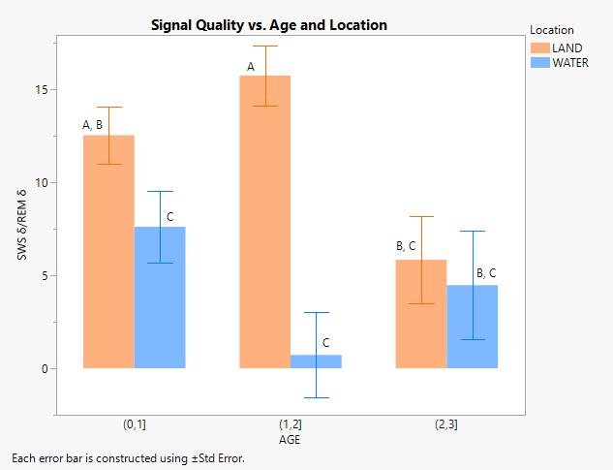

**Figure S2.** Least squares means estimates of signal quality (mean SWS δ/REM δ per sleep cycle) across ages and locations demonstrating significant differences with letter labels. Each error bar is constructed using ±Std Error. Levels not connected by the same letter are significantly different.